AWS Configuration

Contents

[AWS Server Configuration 3](#_Toc38304817)

[Production Server Configuration 4](#_Toc38304818)

[VPC Network Configuration 4](#_Toc38304819)

[Amazon EC2 Configuration 5](#_Toc38304820)

[Amazon RDS (Aurora/MySQL) Configuration 5](#_Toc38304821)

[Amazon ElastiCache Configuration 6](#_Toc38304822)

[Magento Configuration 7](#_Toc38304823)

[AWS Quick Start Configuration 8](#_Toc38304824)

[Amazon Cloud Front 8](#_Toc38304825)

[Amazon EFS 8](#_Toc38304826)

[Staging Server Configuration 8](#_Toc38304827)

[VPC Network Configuration 8](#_Toc38304828)

[Amazon EC2 Configuration 9](#_Toc38304829)

[Amazon RDS (Aurora/MySQL) Configuration 9](#_Toc38304830)

[Amazon ElastiCache Configuration 10](#_Toc38304831)

[Magento Configuration 10](#_Toc38304832)

Document Control

| Sl. No | Version | Date | Description | Author/Reviewer |
| --- | --- | --- | --- | --- |
|  |  |  |  |  |
|  |  |  |  |  |
|  |  |  |  |  |
|  |  |  |  |  |
|  |  |  |  |  |
|  |  |  |  |  |
|  |  |  |  |  |
|  |  |  |  |  |

# AWS Server Configuration

Following is the AWS Architecture for Magento

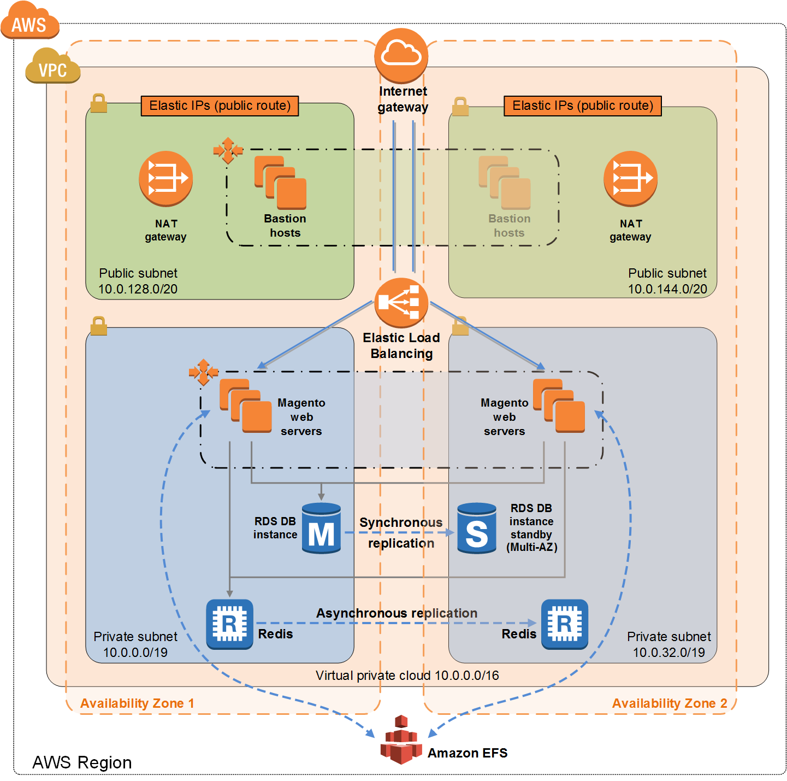

Reference Link:- <https://aws.amazon.com/quickstart/architecture/magento/>

A virtual private cloud (VPC) that spans two Availability Zones, configured with two public and two private subnets.\*

* In a public subnet, a bastion host to provide Secure Shell (SSH) access to the Magento web servers. The bastion host is maintained by an Auto Scaling group that spans multiple Availability Zones, and is configured to ensure there is always one bastion host available.\*
* AWS-managed network address translation (NAT) gateways deployed into the public subnets and configured with an Elastic IP address for outbound internet connectivity. The NAT gateways are used for internet access for all EC2 instances launched within the private network.\*
* Either an Amazon RDS for MySQL or an Amazon Aurora database engine deployed via Amazon RDS in the first private subnet. If you choose Multi-AZ deployment, a synchronously replicated secondary database is deployed in the second private subnet. This provides high availability and built-in automated failover from the primary database.
* An Amazon ElastiCache cluster with the Redis cache engine launched in the private subnets.
* Amazon EC2 web server instances launched in the private subnets.
* Elastic Load Balancing deployed to automatically distribute traffic across the multiple web server instances.
* Amazon EFS created and automatically mounted on web server instances to store shared media files.
* Auto Scaling enabled to automatically increase capacity if there is a demand spike, and to reduce capacity during low traffic times. The default installation sets up low and high CPU-based thresholds for scaling the instance capacity up or down. You can modify these thresholds during launch and after deployment.
* An AWS Identity and Access Management (IAM) instance role with fine-grained permissions for accessing AWS services necessary for the deployment process.
* Appropriate security groups for each instance or function to restrict access to only necessary protocols and ports. For example, access to HTTP server ports on Amazon EC2 web servers is limited to Elastic Load Balancing. The security groups also restrict access to Amazon RDS DB instances by web server instances.

# Production Server Configuration

## VPC Network Configuration

| Parameter label | Parameter name | Default | Description |
| --- | --- | --- | --- |
| Availability Zones | AvailabilityZones | *Asia Specific mumbai 1A,1B* | Choose two Availability Zones that will be used to deploy the components for Magento. The Quick Start preserves the logical order you specify. |
| VPC CIDR | VPCCIDR | 10.0.0.0/16 | CIDR block for the VPC to create. |
| Private subnet 1 CIDR | PrivateSubnet1CIDR | 10.0.0.0/19 | CIDR block for the private subnet in Availability Zone 1. |
| Private subnet 2 CIDR | PrivateSubnet2CIDR | 10.0.32.0/19 | CIDR block for the private subnet in Availability Zone 2. |
| Public subnet 1 CIDR | PublicSubnet1CIDR | 10.0.128.0/20 | CIDR block for the public subnet in Availability Zone 1. |
| Public subnet 2 CIDR | PublicSubnet2CIDR | 10.0.144.0/20 | CIDR block for the public subnet in Availability Zone 2. |
| Allowed bastion external access CIDR | RemoteAccessCIDR | *Requires input*  *Public IP address of office* | The CIDR IP range for external SSH access to the bastion host instances. We recommend that you set this value to a trusted CIDR block. For example, you might want to grant only your corporate network access to the software. |
| Permitted IP range | AccessCIDR | 0.0.0.0/0 | The CIDR IP range that is permitted to access Magento instances. Note that a value of 0.0.0.0/0 will allow access from any IP address. |

## Amazon EC2 Configuration

| Parameter label | Parameter name | Default | Description |
| --- | --- | --- | --- |
| Key pair name | KeyPairName | *Requires input*  *Need to be generate* | An existing public/private key pair, which allows you to connect securely to your instance after it launches. This is the key pair you created in [step 1](https://docs.aws.amazon.com/quickstart/latest/magento/step1.html), when you prepared your AWS account. |
| Bastion AMI OS | BastionAMIOS | Ubuntu 18.04 LTS - Bionic | The Linux distribution for the AMI to be used for the bastion host instances. If you choose CentOS, make sure that you have a subscription to the [CentOS AMI in AWS Marketplace](https://aws.amazon.com/marketplace/pp/B00O7WM7QW" \t "_blank). |
| Bastion instance type | BastionInstanceType | t2.micro | EC2 instance type for the bastion host instances. |
| Web server cluster node instance type | WebServerInstanceType | C5.xlarge | EC2 instance type for web server instances. |
| Minimum number of web server instances | WebServerMinSize | 1 | Minimum number of EC2 instances in the Auto Scaling group of web servers. |
| Maximum number of web server instances | WebServerMaxSize | 3 | Maximum number of EC2 instances in the Auto Scaling group of web servers. |
| Desired number of web server instances | WebServerDesiredCapacity | 1 | Desired number of EC2 instances in the Auto Scaling group before deployment is considered successful. |

## Amazon RDS (Aurora/MySQL) Configuration

| Parameter label | Parameter name | Default | Description |
| --- | --- | --- | --- |
| DB engine | DBEngineType | RDS-MYSQL | Database engine to use for Magento database. Choose Amazon Aurora or MySQL. |
| Amazon Aurora/MySQL DB instance type | DBInstanceClass | db.r3.2xlarge | The name of the compute and memory capacity class of the Amazon RDS(Aurora/MySQL) DB instance. |
| DB name | DBName | MagentoQuickstartDB | Name of the initial database for the Amazon RDS instance. This is a 5-64 character string. It must begin with a letter and contain only uppercase and lowercase letters and numbers. |
| Enable Multi-AZ deployment for DB instance | DBMultiAZ | true | Set to false if Multi-AZ RDS deployment isn’t needed. |
| DB master user name | DBMasterUsername | admin | User name for the database administrator account. This is a 1-16 character alphanumeric string and must start with a letter. |
| DB master password | DBMasterUserPassword | *Requires input* | Password for the database administrator account. This is an 8-32 character string and may include any printable ASCII character except for forward slashes (/), double quotation marks ("), and at signs (@). |
| DB storage size (in GiB) | DBAllocatedStorage | 16 | Size of the database (in GiB). You can enter a value between 5 and 4,096 GiB. If you set the DB Storage Type parameter to io1 (Provisional IOPS), you must allocate at least 100 GiB in storage, and the DB IOPS value must be 1,000 at the minimum. |
| DB storage type | DBStorageType | gp2 | Storage type associated with the database instance. You can choose standard (Magnetic), gp2 (General Purpose SSD), or io1 (Provisioned IOPS SSD). |
| DB IOPS | DBIops | 1000 | Provisioned IOPS for DB storage. Used only when you set the DBStorageType parameter to io1 (that is, Provisioned IOPS). |
| Automatic upgrade to new Amazon Aurora/MySQL minor versions | DBAutoMinorVersionUpgrade | true | Determines whether the DB instance will automatically be upgraded to new Amazon Aurora or MySQL minor versions as they are supported by Amazon RDS. Set to false to disable auto-upgrades. |
| DB backup retention period | DBBackupRetentionPeriod | 7 | Number of days for which automatic DB snapshots are retained. |

## Amazon ElastiCache Configuration

|  |  |  |  |
| --- | --- | --- | --- |
| Parameter label | Parameter name | Default | Description |
| ElastiCache automatic failover | ElastiCacheAutomaticFailover | true | Automatic failover setup. Select false to disable automatic failover. |
| ElastiCache node type | ElastiCacheNodeType | cache.m4.large | Compute and memory capacity class of the ElastiCache instance. |
| Number of ElastiCache nodes | ElastiCacheNodes | 2 | Number of nodes in the ElastiCache cluster. This must be a value between 2 and 5. |

## Magento Configuration

|  |  |  |  |
| --- | --- | --- | --- |
| Parameter label | Parameter name | Default | Description |
| Public DNS name | DNSName | *Optional* | DNS name for the Magento site. If you provide a DNS name, you should create an alias for the ELB load balancer after stack creation. |
| Administrator first name | AdminFirstName | *Requires input* | First name of the Magento site administrator. |
| Administrator last name | AdminLastName | *Requires input* | Last name of the Magento site administrator. |
| Administrator email | AdminEmail | *Requires input* | Email of the Magento site administrator. |
| Administrator user name | AdminUserName | *Requires input* | User name of the Magento site administrator. |
| Administrator password | AdminPassword | *Requires input* | Password for the Magento site administrator. This is an 8-32 character string that consists of uppercase and lowercase letters, numbers, and symbols. |
| Email address to notify | NotificationEmail | *Requires input* | Email address to notify if there are any scaling operations. |
| Magento currency | MagentoCurrency | USD | The currency you’d like to use to display prices in the Magento store. |
| Magento language | MagentoLanguage | en\_US | The language you’d like to use for the text that appears throughout the Magento store. |
| Magento timezone | MagentoTimezone | America/Los\_Angeles | The time zone setting that specifies the primary market served by the Magento store. |
| S3 file path to download Magento | MagentoReleaseMedia | *Requires input* | The Amazon S3 path to download the magento .tar.gz file (https://s3-<region>.amazonaws.com/mybucket/Magento-CE-2.3.2\_sample\_data-2019-06-13-04-34-43.tar.gz). |
| Magento Version (2.1 or 2.3) | MagentoVersion | 2.3 | Magento version (2.1 or 2.3) |
| SSL Certificate ARN | SSLCertificateId | *Optional* | The ARN of the SSL certificate to use for the web server. |

## AWS Quick Start Configuration

|  |  |  |  |
| --- | --- | --- | --- |
| Parameter label | Parameter name | Default | Description |
| Quick Start S3 Bucket Name | QSS3BucketName | aws-quickstart | S3 bucket name for the Quick Start assets. The bucket name can include numbers, lowercase letters, uppercase letters, and hyphens (-). It cannot start or end with a hyphen (-). |
| Quick Start S3 Key Prefix | QSS3KeyPrefix | quickstart-magento/ | S3 key prefix for the Quick Start assets. The key prefix can include numbers, lowercase letters, uppercase letters, hyphens (-), and forward slashes (/). |

## Amazon Cloud Front

This is a separate service and needed.

Amazon CloudFront is a fast content delivery network (CDN) service that securely delivers data, videos, applications, and APIs to customers globally with low latency, high transfer speeds, all within a developer-friendly environment. CloudFront is integrated with AWS – both physical locations that are directly connected to the AWS global infrastructure, as well as other AWS services. CloudFront works seamlessly with services including AWS Shield for DDoS mitigation, Amazon S3, Elastic Load Balancing or Amazon EC2 as origins for your applications, and Lambda@Edge to run custom code closer to customers’ users and to customize the user experience. Lastly, if you use AWS origins such as Amazon S3, Amazon EC2 or Elastic Load Balancing, you don’t pay for any data transferred between these services and CloudFront.

## Amazon EFS

30 TB

Amazon EFS is use to store shared media files.

# Staging Server Configuration

## VPC Network Configuration

| Parameter label | Parameter name | Default | Description |
| --- | --- | --- | --- |
| Availability Zones | AvailabilityZones | *Asia Specific mumbai 1A,1B* | Choose two Availability Zones that will be used to deploy the components for Magento. The Quick Start preserves the logical order you specify. |
| VPC CIDR | VPCCIDR | 10.0.0.0/16 | CIDR block for the VPC to create. |
| Private subnet 1 CIDR | PrivateSubnet1CIDR | 10.0.0.0/19 | CIDR block for the private subnet in Availability Zone 1. |
| Public subnet 1 CIDR | PublicSubnet1CIDR | 10.0.128.0/20 | CIDR block for the public subnet in Availability Zone 1. |
| Allowed bastion external access CIDR | RemoteAccessCIDR | *Requires input* | The CIDR IP range for external SSH access to the bastion host instances. We recommend that you set this value to a trusted CIDR block. For example, you might want to grant only your corporate network access to the software. |
| Permitted IP range | AccessCIDR | 0.0.0.0/0 | The CIDR IP range that is permitted to access Magento instances. Note that a value of 0.0.0.0/0 will allow access from any IP address. |

## Amazon EC2 Configuration

|  |  |  |  |
| --- | --- | --- | --- |
| Parameter label | Parameter name | Default | Description |
| Key pair name | KeyPairName | *Requires input* | An existing public/private key pair, which allows you to connect securely to your instance after it launches. This is the key pair you created in [step 1](https://docs.aws.amazon.com/quickstart/latest/magento/step1.html), when you prepared your AWS account. |
| Bastion AMI OS | BastionAMIOS | Ubuntu 18.04 LTS - Bionic | The Linux distribution for the AMI to be used for the bastion host instances. If you choose CentOS, make sure that you have a subscription to the [CentOS AMI in AWS Marketplace](https://aws.amazon.com/marketplace/pp/B00O7WM7QW" \t "_blank). |
| Bastion instance type | BastionInstanceType | t2.nano | EC2 instance type for the bastion host instances. |
| Web server cluster node instance type | WebServerInstanceType | a1.large | EC2 instance type for web server instances. |
| Minimum number of web server instances | WebServerMinSize | 1 | Minimum number of EC2 instances in the Auto Scaling group of web servers. |
| Maximum number of web server instances | WebServerMaxSize | 3 | Maximum number of EC2 instances in the Auto Scaling group of web servers. |
| Desired number of web server instances | WebServerDesiredCapacity | 1 | Desired number of EC2 instances in the Auto Scaling group before deployment is considered successful. |

## Amazon RDS (Aurora/MySQL) Configuration

| Parameter label | Parameter name | Default | Description |
| --- | --- | --- | --- |
| DB engine | DBEngineType | Amazon Aurora | Database engine to use for Magento database. Choose Amazon Aurora or MySQL. |
| Amazon Aurora/MySQL DB instance type | DBInstanceClass | db.t2.small | The name of the compute and memory capacity class of the Amazon RDS(Aurora/MySQL) DB instance. |
| DB name | DBName | MagentoQuickstartDB | Name of the initial database for the Amazon RDS instance. This is a 5-64 character string. It must begin with a letter and contain only uppercase and lowercase letters and numbers. |
| Enable Multi-AZ deployment for DB instance | DBMultiAZ | true | Set to false if Multi-AZ RDS deployment isn’t needed. |

## Amazon ElastiCache Configuration

|  |  |  |  |
| --- | --- | --- | --- |
| Parameter label | Parameter name | Default | Description |
| ElastiCache automatic failover | ElastiCacheAutomaticFailover | true | Automatic failover setup. Select false to disable automatic failover. |
| ElastiCache node type | ElastiCacheNodeType | cache.t2.small | Compute and memory capacity class of the ElastiCache instance. |
| Number of ElastiCache nodes | ElastiCacheNodes | 2 | Number of nodes in the ElastiCache cluster. This must be a value between 2 and 5. |

## Magento Configuration

| Parameter label | Parameter name | Default | Description |
| --- | --- | --- | --- |
| Public DNS name | DNSName | *Optional* | DNS name for the Magento site. If you provide a DNS name, you should create an alias for the ELB load balancer after stack creation. |
| Administrator first name | AdminFirstName | *Requires input* | First name of the Magento site administrator. |
| Administrator last name | AdminLastName | *Requires input* | Last name of the Magento site administrator. |
| Administrator email | AdminEmail | *Requires input* | Email of the Magento site administrator. |
| Administrator user name | AdminUserName | *Requires input* | User name of the Magento site administrator. |
| Administrator password | AdminPassword | *Requires input* | Password for the Magento site administrator. This is an 8-32 character string that consists of uppercase and lowercase letters, numbers, and symbols. |
| Email address to notify | NotificationEmail | *Requires input* | Email address to notify if there are any scaling operations. |
| Magento currency | MagentoCurrency | USD | The currency you’d like to use to display prices in the Magento store. |
| Magento language | MagentoLanguage | en\_US | The language you’d like to use for the text that appears throughout the Magento store. |
| Magento timezone | MagentoTimezone | America/Los\_Angeles | The time zone setting that specifies the primary market served by the Magento store. |
| S3 file path to download Magento | MagentoReleaseMedia | *Requires input* | The Amazon S3 path to download the magento .tar.gz file (https://s3-<region>.amazonaws.com/mybucket/Magento-CE-2.3.2\_sample\_data-2019-06-13-04-34-43.tar.gz). |
| Magento Version (2.1 or 2.3) | MagentoVersion | 2.3 | Magento version (2.1 or 2.3) |
| SSL Certificate ARN | SSLCertificateId | *Optional* | The ARN of the SSL certificate to use for the web server. |

## Amazon EFS

10 TB